HADOOP COMMENT’S

CODE :- start-dfs.sh
- Start Hadoop Server.
Output :-
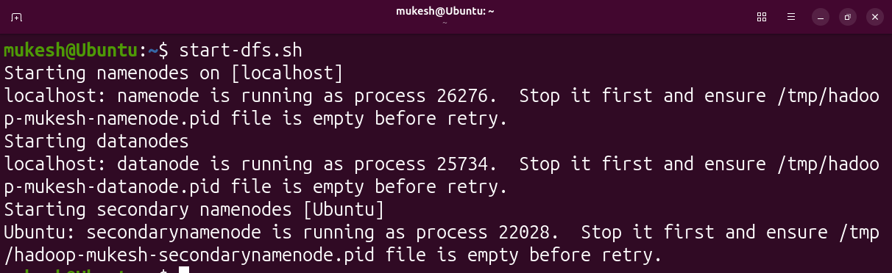
CODE :- jps
- Check background which are process running.
Output :-
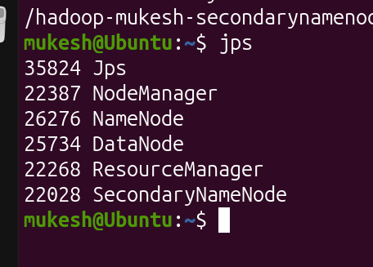
Secondary Name Node --> to helps assign task of data node.
CODE :- hdfs dfs -ls /
- it's return list of files inside directory.
Output :-
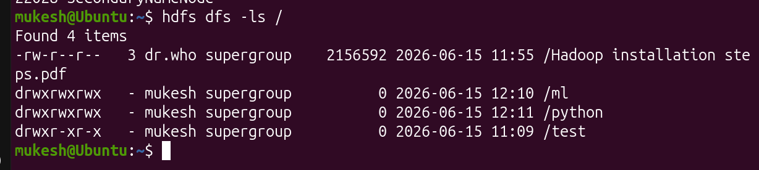

CODE :- hdfs dfs -mkdir /{Python,ML}
it's creates a Python and ML Folders inside Current directory.
Output :
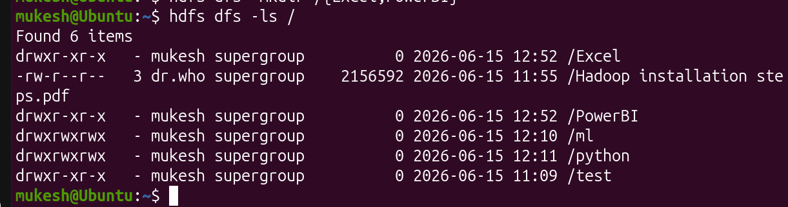
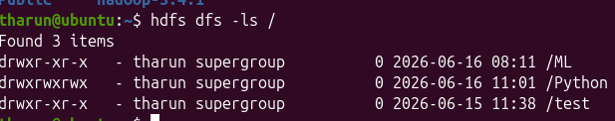
CODE :- hdfs dfs -mkdir /Excel/{CSV,Json}
it's create a D1 and D2 Folders inside Python Folder.
Output :-
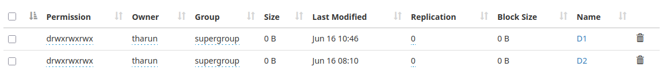
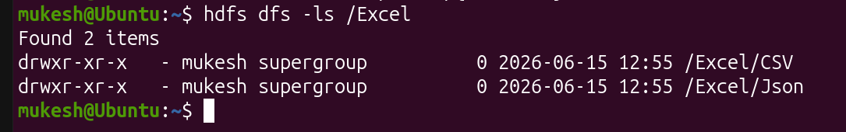
CODE :- hdfs dfs -mkdir /PowerBI/{Dax,Kpi}
it's create a D1 and D2 Folders inside ML Folder.
Output :-
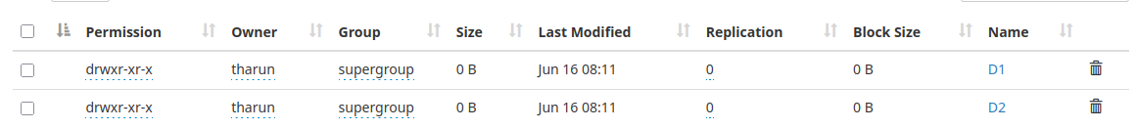
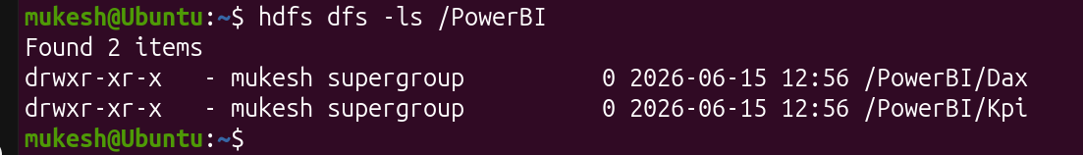
CREATE A FILES:-
> Files only create a Outside of Hadoop.
> First create file in outside of Hadoop.
> Then Push the File inside Hadoop.
> We use put command to Push the file [local to Hadoop].
> We want to extract the file mean we use get command to get the file in Hadoop[Hadoop to local].
CODE :- cat > Excel_CSV_file1.txt
Now create file .Then Push file inside of Hadoop.
Output :-
CODE :- hdfs dfs -put Python_d1_file1.txt /Python/D1
Push file inside the Hadoop.
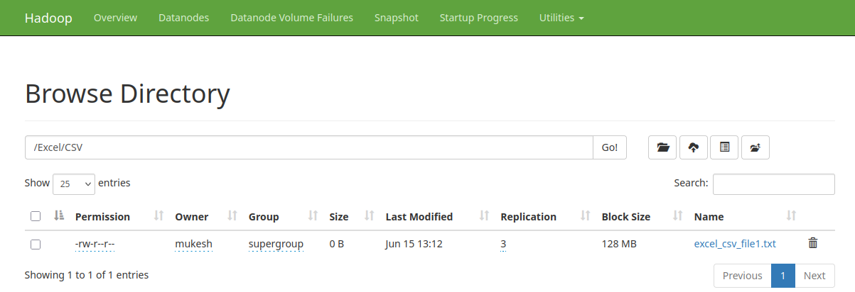

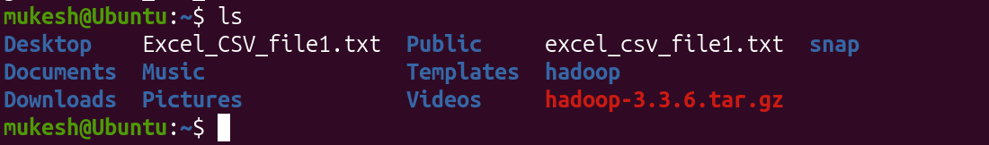

CODE :- hdfs dfs -get /Python/D1/python_d1_file1.txt
Get back file in local server.
Output :-
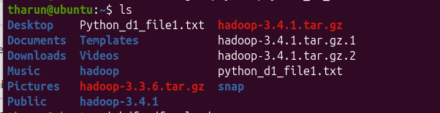
CODE :- hdfs dfs -rmdir /Python/D2
The rmdir command only remove the folder directory .
Output :-

CODE :- hdfs dfs -rm /Python/D1/python_d1_file1.txt
it’s remove file.
Output :-
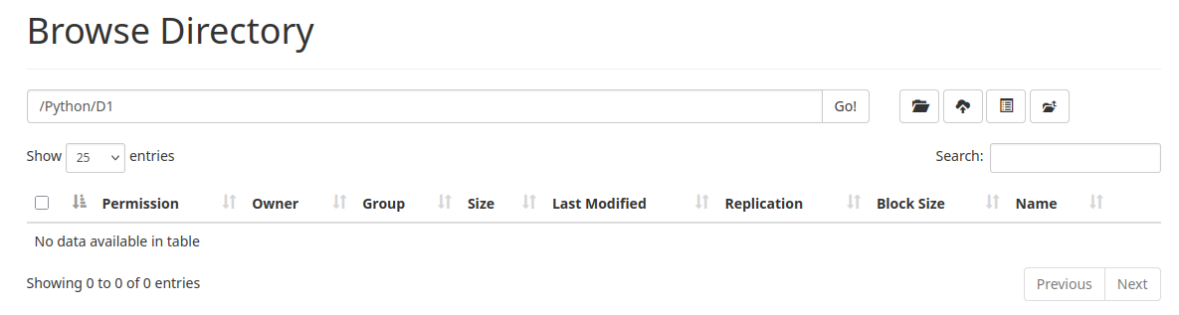

CODE :- hdfs dfs -rm -r /Python/D1
It’ remove Directory and file or folder.
Output :-

CODE :- hdfs dfs -chmod 777 /Python/D2
it’s used to change mode to directory
Output :-

